

Toomey Chiropractic Center
5355 Library Road
Bethel Park, Pa 15102
(412)-854-2900 georgetoomeydc@gmail.com
Outcomes for 20 Clients: 8 Weeks on the Ideal Protein Protocol
Toomey Chiropractic, offers medically supervised weight loss services using the Ideal Protein Weight Loss Method, a low fat, low carb, adequate protein nutritional ketogenic protocol. We provide weekly coaching, extensive client education, and long-term maintenance support to help keep the weight off. The outcomes, below, are from our clients, and they are typical for those that follow the Ideal Protein protocol.
Summary: This data is from 20 of our clients (10 men and 10 women) who did the Ideal Protein protocol for 8 weeks. A wide range of ages are represented: three were 25-39 years old, seven were 40-50, seven were 51-60, and three were 61-73. Men lost an average of 4.1 pounds per week and women lost an average of 3.91 pounds per week.
8 WEEKS on Ideal Protein: Summary of Results
 | Males |  |  |  |  | Females
 | Weight (lbs) |  | BMI |  | Weeks to 10% Lost | Weight (lbs) |  | BMI |  | Weeks to 10% Lost
 | Prior | Post | Prior | Post | Weeks to 10% Lost | Prior | Post | Prior | Post | Weeks to 10% Lost
Average | 277.2 | 239.3 | 39.8 | 34.4 | 5.5 | 196.5 | 170.9 | 32.3 | 28.1 | 5.6
StD Dev | 61.3 | 54.6 | 7.9 | 7.0 | 1.8 | 40.3 | 35.0 | 6.1 | 5.3 | 1.1

BMI is a key medical marker and now considered the “5th vital sign”. 15 of the 20 participants dropped a full BMI obesity classification in just 8 weeks. Five remained in the same category. Of the five that did not drop a Category, 2 were at the top end of the Overweight category and at assessment were 25.4 and25.2. Three were in Class 3 which has no upper limit and many of these clients saw dramatic BMI reductions in 8 weeks (48.2-41.3, 53-46, 45-42).
BMI Classification Results
 | Normal | Overweight | Class 1 | Class 2 | Class 3
Prior | 0 | 5 | 6 | 3 | 6
Post | 3 | 8 | 3 | 3 | 3

The loss of the first 5-10% of initial body weight is when the greatest health improvements occur, according to current research. With these 20 clients, it took men an average of 5.5 weeks to lose the first 10% of initial body weight and women took an average of 5.6 weeks.
8 Weeks on the Ideal Protein Protocol – Males

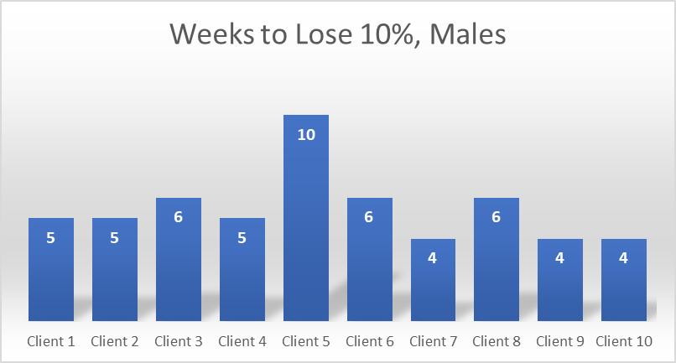

8 Weeks on the Ideal Protein Protocol
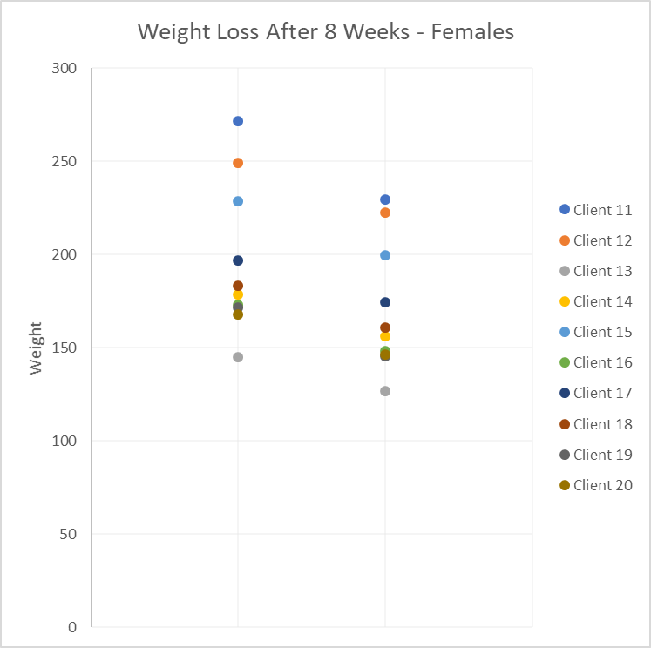
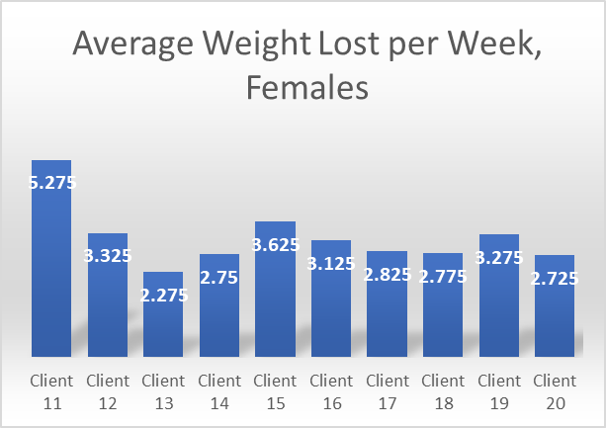

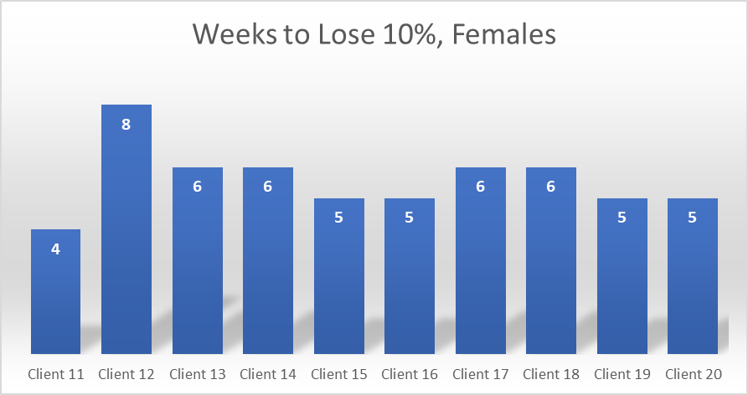

BMI Reduction After 8 Weeks on Ideal Protein
